WEEK – 5

HEALTH CARE DATA ANALYSIS

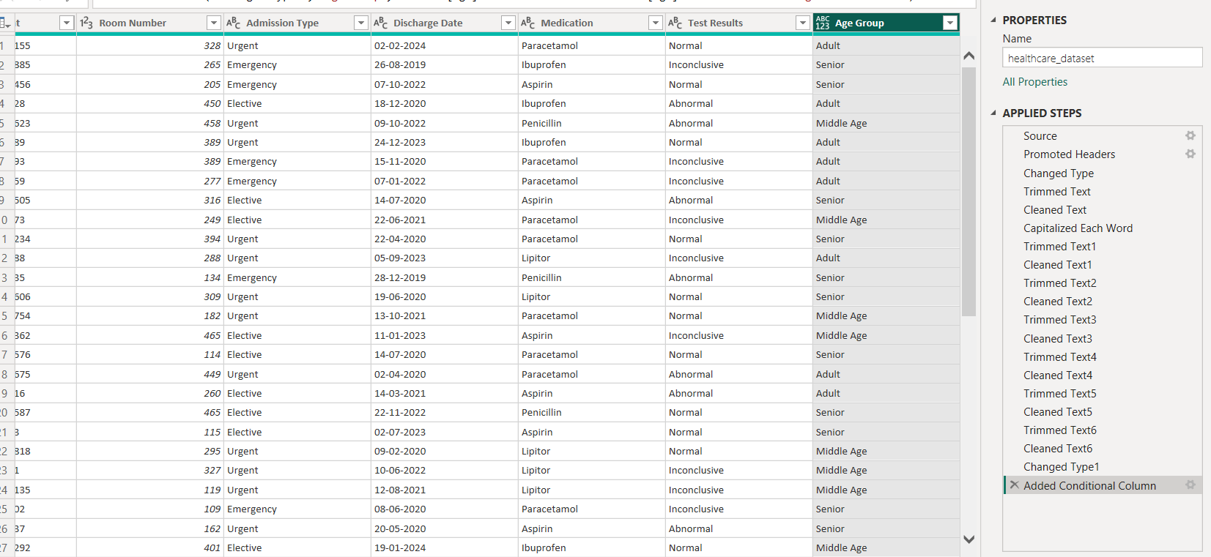
Step 1 : Transform data set and add a column called Age Group.

Step 2 : Create a new queries named it as Billing 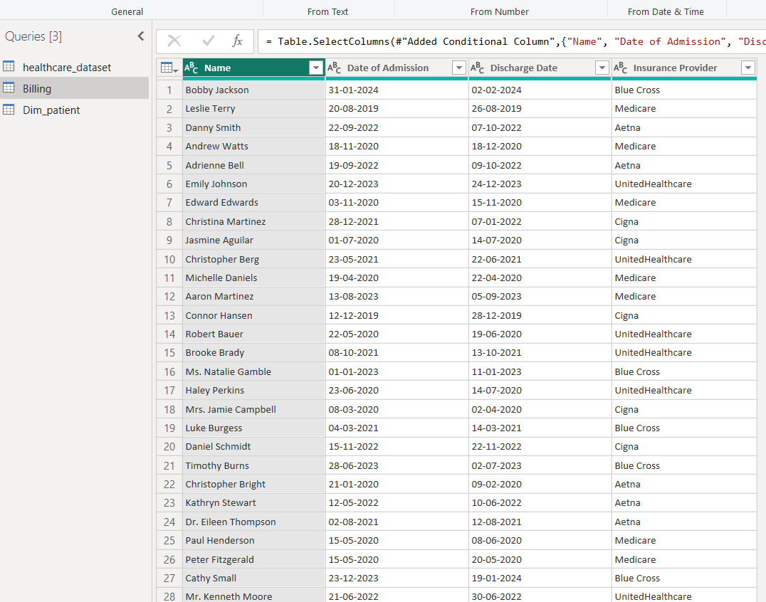

Step 3: Create another querie called Dim_patient in that create patient ID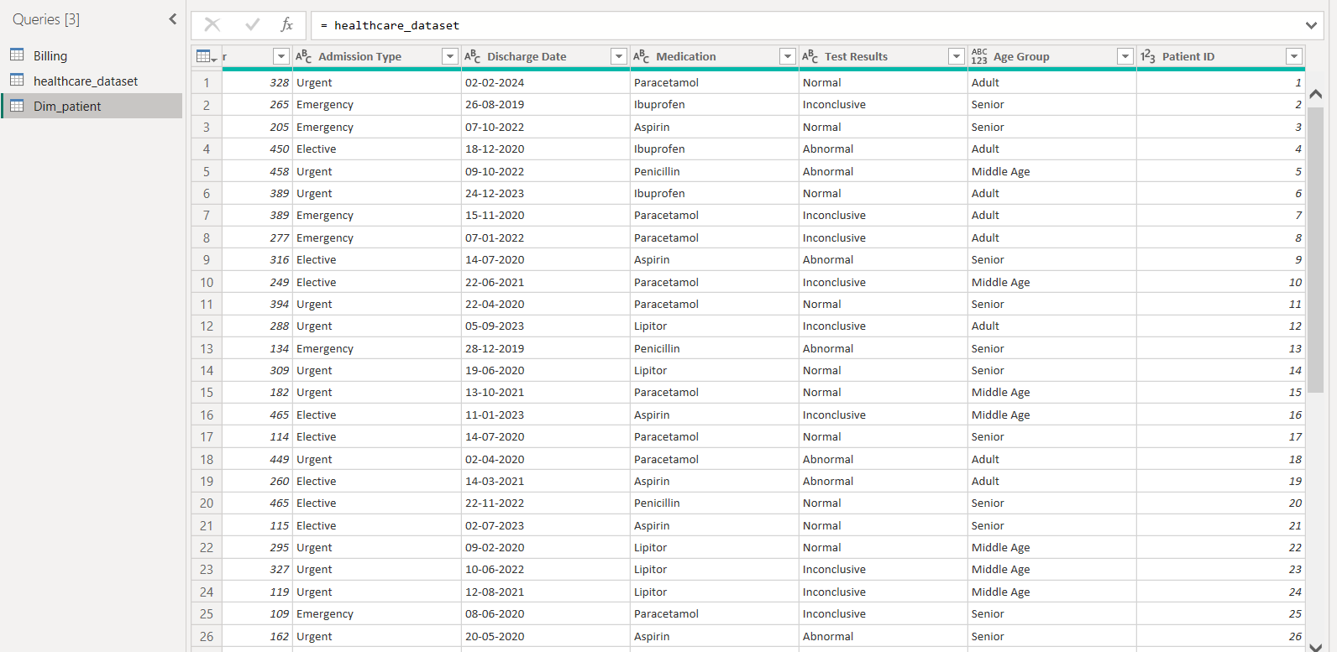

Step 4 : create another queries called Dim_ Admission and in that create Addmission ID.

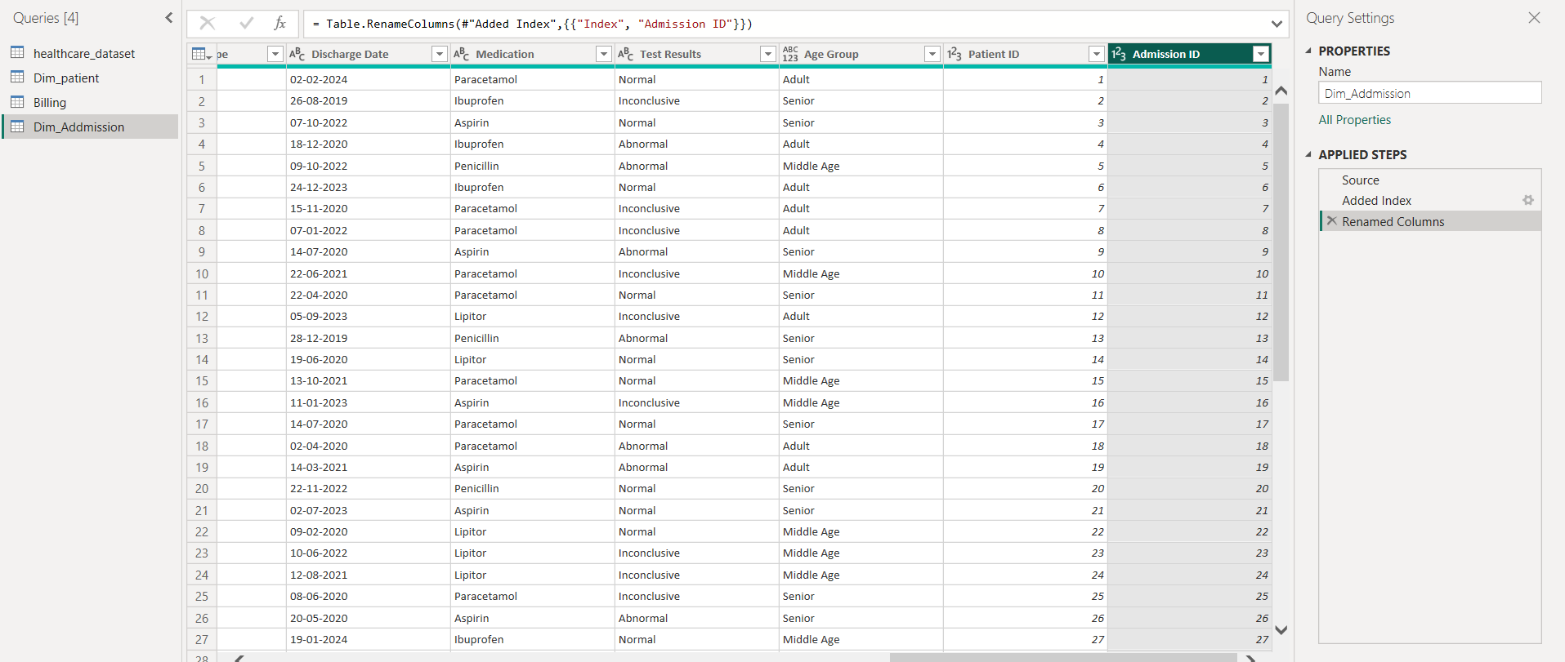

Step 5 : Atlast it look like

